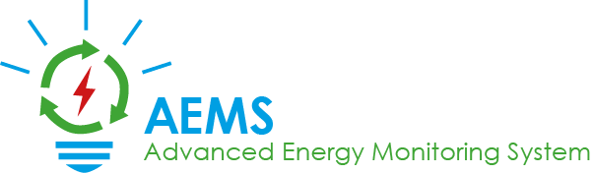

REPORT: SPECIAL PRIZE SUSTAINABILITY

LUKAS KNOLL, NIKLAS GRAF, SEBASTIAN MANDL

2018

# General Information

## 1.1 School

**Name:** HTBLA Grieskirchen

**Address:** Parzer Schulstraße 1

4710 Grieskirchen

Austria

**Phone:** +43 7248 64315 -0

**E-Mail:** [office@htl-grieskirchen.at](mailto:office@htl-grieskirchen.at)

## 1.2 Project Team

**Members:** Lukas Knoll, 5B

Niklas Graf, 5B

Sebastian Mandl, 5B

**Project Manager:** Lukas Knoll

**Address:** Grübl 28

4633 Kematen am Innbach

**Phone:** +43 650 678 05 67

**E-Mail:** [knolli398@gmail.com](mailto:knolli398@gmail.com)

**Supervisor:** DI Josef Doppelbauer

**Phone:** +43 7248 6431530

**E-Mail:** [j.doppelbauer@htl-grieskirchen.at](mailto:j.doppelbauer@htl-grieskirchen.at)

## 1.3 Project Info

**Project Number:** J180208

**Project Name:** AEMS – Advanced Energy Monitoring System

## 1.4 Category and Specification

**Category:** Special Prize for Sustainability

**Specification:** Improvement of energy efficiency

# 2 The origins of the AEMS project

## 2.1 Selection of the topic

When searching for an adequate topic for our diploma thesis, we came across the topic of energy efficiency. The energy consumption in many areas of the world is increasing, and the world population keeps rising too. We saw a lot of potential to save otherwise wasted energy if people would just know how much energy they are consuming.

[Coincidentally](https://www.dict.cc/englisch-deutsch/coincidentally.html) we came across a request by the “Energiegenossenschaft Eferding”. They were looking for a simple tool which could convert raw energy consumption data from excel files into meaningful visualisations and statistics. Sadly, this project alone was too small in order to be considered as an adequate diploma thesis for three students, so we began to think about other features which would enhance the tool. And thus, the idea of AEMS was born.

## 2.2 Goals

The purpose of this diploma thesis is to raise awareness about one’s own energy consumption. Utilizing our tool, one can create statistics and reports in predefined periods using only the meters of one’s choice. These statistics enable one to see where and when the energy consumption has been exceedingly high and to deploy fitting countermeasures. Additionally, our tool can send push notifications directly to one’s mobile device if the energy consumption rises or drops significantly. Our simple, custom made programming language AEMS-Script can be used to adjust these notifications to your convenience.

All of these features serve one purpose: To decrease the energy consumption on a big scale in order to do our part in order to the environment.

## 2.3 Project management

## 

We decided to go for a classic project management method: The waterfall model. Every big step (layout done, database created, …) was declared as a milestone.

The work packages have been defined and estimated by the project team. A status report has been created regularly in order to reveal any troubles the project might encounter.

After the definition of all functions the tool must cover, a detailed performance specification was created and reviewed by our client.

## 2.4 Distribution of tasks

Due to the fact that the project team has known each other for about four years, the assignment of tasks was very straight forward.

Lukas was responsible for the entire project management, the Android-App and the frontend of the web applications.  
Sebastian was in charge of creating the database and a corresponding REST API. He also designed the algorithm to be used for spotting odd energy usage. Furthermore, he implemented custom meter types using a raspberry pi.  
Niklas has created the tool which extracts raw data from excel files and sends them to the database. He was also responsible for the backend of the web applications, the displaying and download of statistics and the server configuration.

# 3 Project realisation and vision

## 3.1 Innovation

AEMS is not the first monitoring tool ever created. However, conventional tools rely on one specific meter type, or they are proprietary to one company. Furthermore, other conventional software often does not offer anomaly detection or a warning system.

What makes us special?

Simple extension of custom meter types. They just need to be installed on a raspberry pi with an internet connection to be integrated within our service.

Anomaly detection and warning system: The user can decide to consider other metrics (like temperature, time of day, …) in their settings to have 100 percent control about when a push notification should be sent. Also, these other metrics can be included within the user’s statistics.

## 3.2 Implementation

During the planning phase of the project we had to invest some time into researching the best technologies for our undertaking. Given that the Android-App must be written in Java anyway, and we had plenty of experience with this language, we decided to stick to Java technologies.

The tool for converting excel files was written in Java, as were some class libraries in order to support the individual sub-projects with methods to access the API, and thus, the database.  
The web appearance is shaped by plain (X)HTML, CSS and JavaScript. Some frameworks, like Bootstrap and jQuery, were used to speed up the development. For the server backend, JavaServer Faces was utilized.

We have decided to store our data in a Postgre SQL database, as it is very similar to oracle and also free to use. For the database API, GraphQL was utilized in order to minimize the number of requests that need to be sent to the server.

## 3.3 Results

The development phase is completed and the tool is about to be tested under real conditions. The project is currently in the deployment phase.

* The tool enables the user to automatically fetch excel files from the “Netzonline” service and to review the data as statistics and reports.
* Statistics can be downloaded as PDF. Reports can combine multiple statistics and then also be downloaded as PDF.
* A software for raspberry pi’s has been developed in order to create custom meter types.
* A custom programming language has been developed in order to customize push notifications beyond the possibilities of the simple user interface.
* An Android-App has been created to get informed when one is on the way.
* An administration web interface has been developed for managing the users of AEMS.

Pictures of the web interface and the android app can be found below.

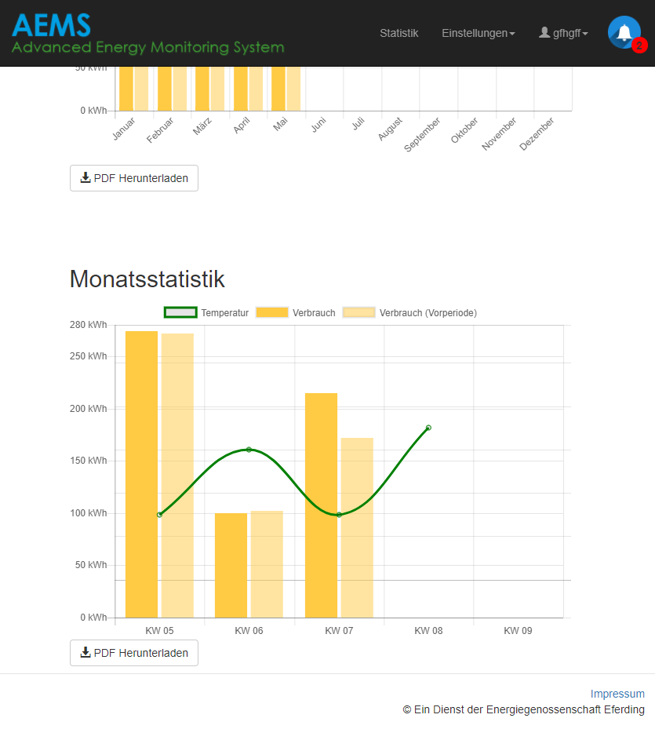  
Image 1: Index-Page with various statistics (random data)

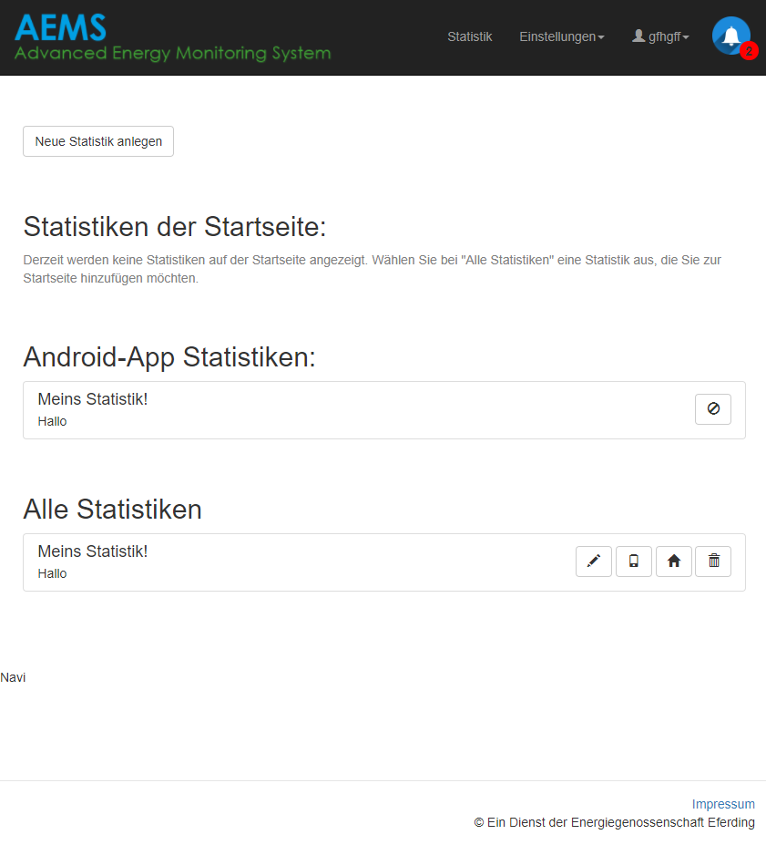  
Image 2: Statistics overview page

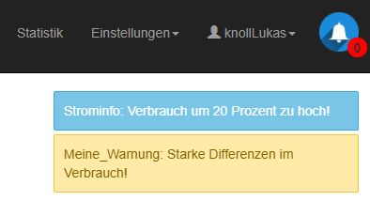  
Image 3: Notifications

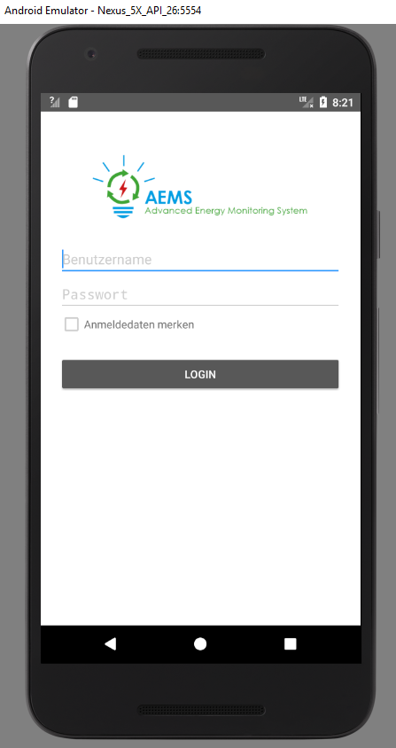  
Image 4: Login screen of Android App

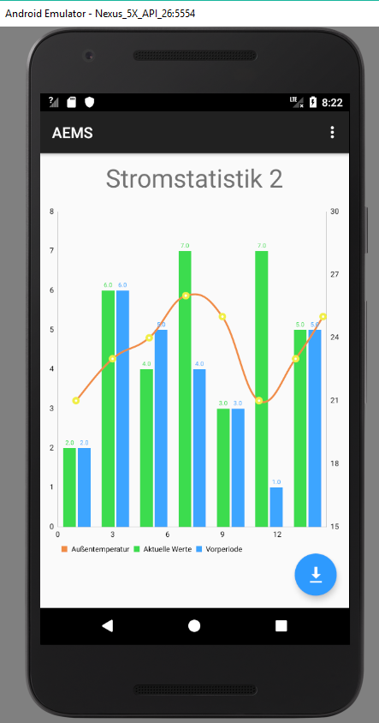  
Image 5: Statistic display in App

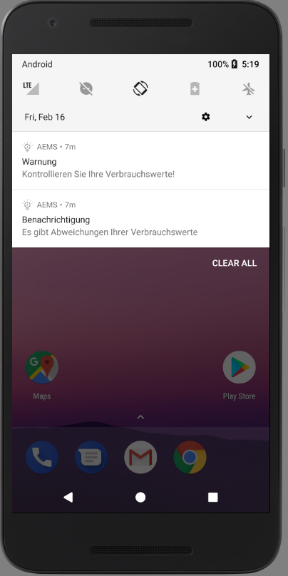  
Image 6: Push notifications of App